ARTIFICAL INTELLIGENCE PROJECT REPORT

Home Automation with Speech to text

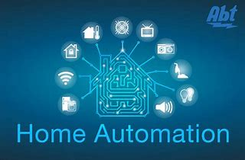

**DONE BY:**

Kajal Kumari (11805135)

Oinam Kunjarani Devi (11804315)

Shradha kumari (11804273)

B. Upendar Reddy (11805157)

**SUBMITTED TO:**

Ankita Wadhawan mam

**Objective**: objective of this project is to achieve home automation with speech into recognition. now, we talk about what is home automation? **Home automation** or **domotics** is building automation for a home, called a **smart home** or **smart house**. A home automation system will control lighting, climate, entertainment systems, and appliances .In this project we control the light of home with our voice and if it is done it give result in written form with voice.

**METHOLOGY/ALGORITHM**

1. Speech into text

2. light on/off with ifttt (home automation)

3. Thing-speak using for value update on cloud

4. final code and finalize the project

**Speech into text:**

This section is done B.Upendar Reddy(11805157)

Speech Recognition is an important feature in several applications used such as home automation, artificial intelligence, etc. speech into text is used google audio.i write the code for speech into text.

**Light on/off(IFTT):**

This section is done by shradha kumari(11804273)

Control the light using IFTT. IFTT stand for “ IF This, Then That”. IFTT is an easy way to automate tasks that might otherwise be repetitive or unable to talk to each other. It works like this: users are guided through a process to make simple scripts, aka”recipes”, where some type of event in one device or service automatically triggers an action in another.

**Point To Remember:**

You can only have one event trigger and one action. In some cases, you’d likely want to have more than one action, and with IFTT that’s not possible. I do all the setting IFTTT and managing the command.

**Thing-speak for value update on cloud:**

This part is done by oinam Kunjarani Devi (11804315)

Thing-speak is an IoT analytics platform service that allows you to aggregate, visualize and analyze live data streams in the cloud. Thing-Speak provides instant visualizations of data posted by your devices to Thing-Speak.

Basically we work on channel and field and in this project we used only one field for value update and we get a graph

Graph is based on command.

**Finalize the all module and make working project**:

This part is done by kajalkumari (11805135)

Now we finalize the project and firstly we discuss the algorithm then we see the code and code for audio record

**Algorithm**

1. Retrieve the API from Thing-speak

2. Set the instruction with the help of IFTTT.

3. write the code for audio record.

4. write the code for speech text into text form

SCREENSHOTS OF OUTPUT:

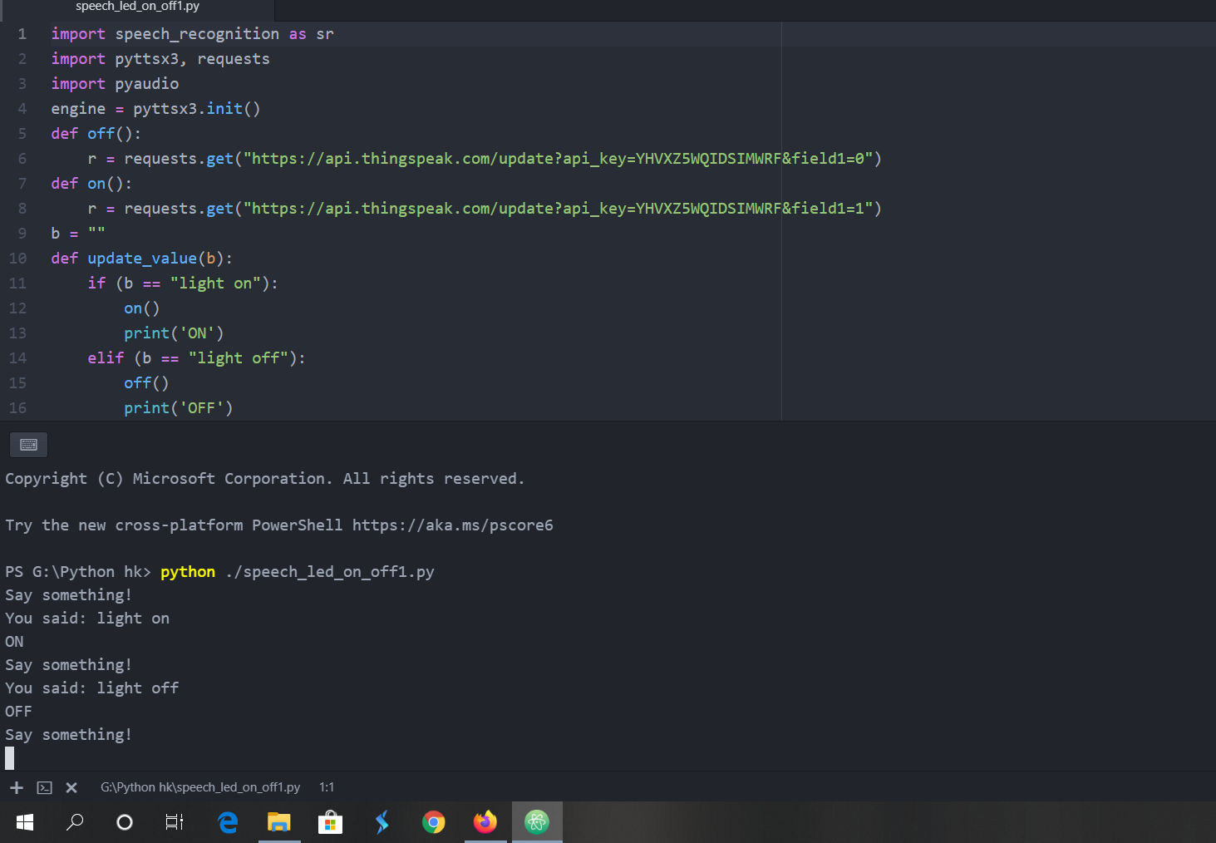

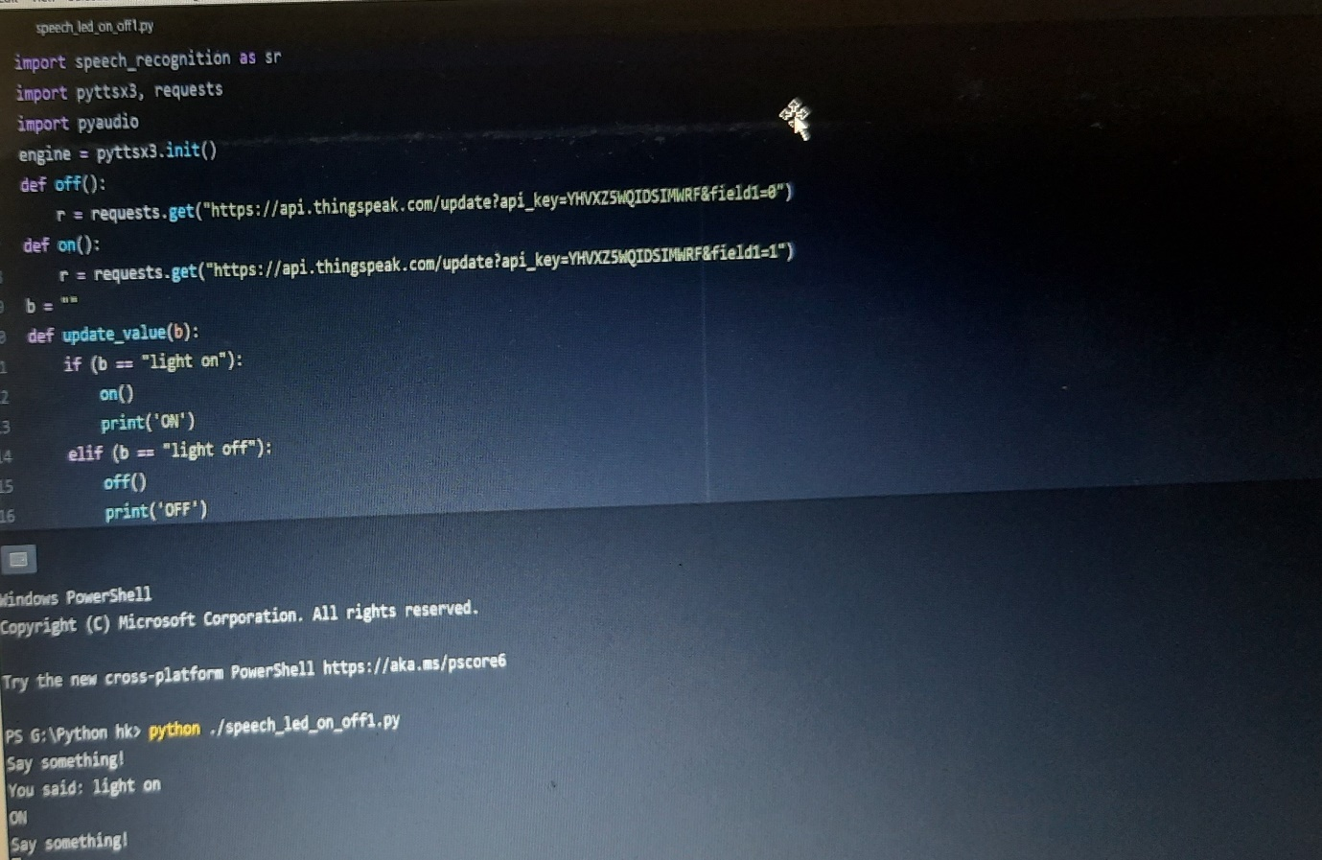

It may be small project we can use on higher level .for example we can use this idea in university ,homes, office, etc. if we can apply this process on our university we can utilize electricity in efficient way.

**How different to other automation !**

In this project we can control homes lighting with the help of Google assistant (this is done by IFTTT App).

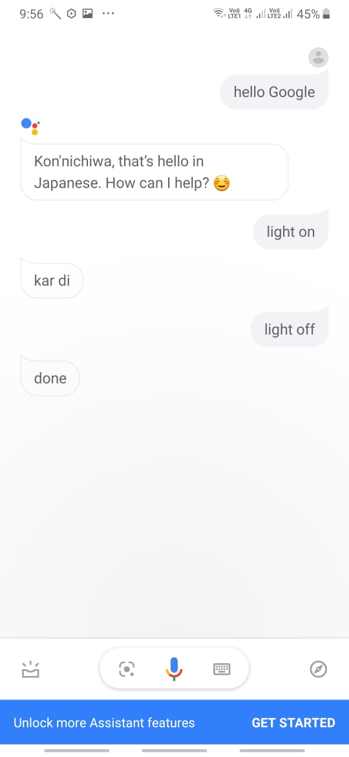WHY WE USE API KEY?

If we use API we can update data on cloud.

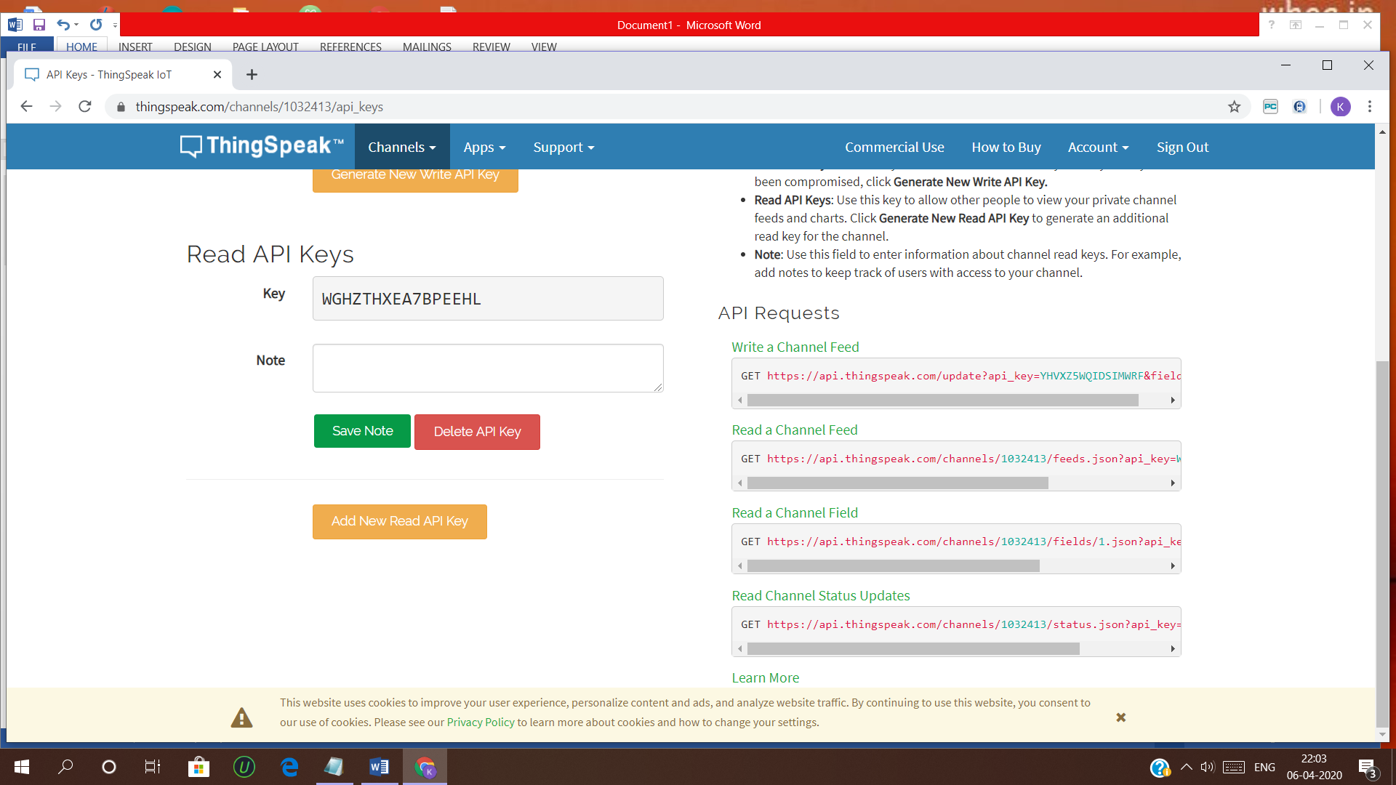

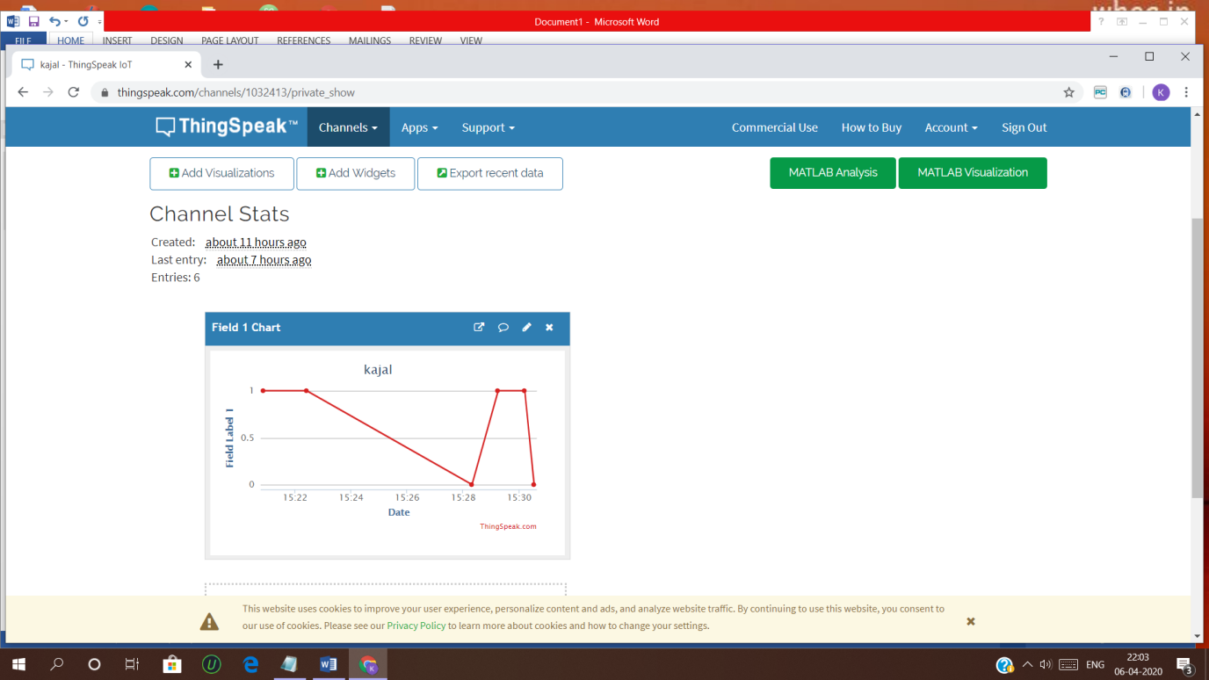

THANK YOU